Performance assessment of PID-type furnace process control system with LQG benchmarking
Tao Fang¹
1. Key Lab for IOT and Information Fusion Technology of Zhejiang, Information and Control Institute, Hangzhou Dianzi University, Hangzhou 310018, P R China
E-mail: tfyzft@foxmail.com

Abstract: This paper focuses on the control system performance in industrial control processes and evaluates the controller performance using the assessment criterion based on linear quadratic Gaussian (LQG). The LQG performance benchmark curve is determined by the numerical calculation method, which avoids the calculation of the complex interaction matrix. This method depends on the model-based steady-state optimization technique, combines the LQG benchmark and the performance assessment of the control system. The control performance of the process system under different control strategies is described by establishing a series of the steady-state optimization problems. Compared with existing assessment algorithms, our method provides a simpler and more effective method to evaluate the performance of IMC-PID control system for both model match and model mismatch cases. Finally, the effectiveness of the method is verified by the experiments on a heating furnace.
Key words: Control system performance assessment; LQG performance benchmark; IMC-PID

1 Introduction
High-performance controllers are necessary for high-performance control systems, however, 60% industrial control circuits currently have a variety of performance defects [1], such as the controller parameter design is unreasonable, the controller structure is not suitable, the process disturbance characteristics have changed during long time operation, equipment fault , and the device is running incorrectly. Even if the controller works normally in the initial debugging, its performance degrades because of the long term running without parameter adjustment. With the increasing use of control systems in industrial production processes, the study of system performance assessment of controllers has attracted more and more attention [2,3]. Some of these problems can be solved by appropriate parameter adjustments. For some problems, the performance of a controller can be improved by adopting a new control strategy or modifying hardware devices.
Controller performance assessment has become one of the important directions in the research field. In 1970, Box and Jenkins [4] established the minimum variance control (MVC) theory. In 1978, DeVries and Wu [5] proposed the idea of control performance ​​assessment. However, people began to gradually recognize the importance of control performance assessment when Ender [6] surveyed the problems of the control performances in the process industry. In 1989, Harris [7] first proposed a method to evaluate the performance of single-loop control based on the MVC with the Harris index. In 1995, Tyler and Morari [8] extended the Harris indicators to unstable and non-minimum phase systems. However, because of too much MVC control action and poor robustness, the practical use is very limited. In 1999, Huang et al. [9] proposed a linear quadratic Gaussian (LQG) optimal control based on MVC as a benchmark for performance assessment, which considers the input and output and provides a practical lower bound of performance. In 2010, Danesh et al. [10] extended the LQG benchmark to the cascade control loop.
Although control system performance assessment techniques have achieved some results in both theoretical and industrial applications in recent years, most of the existing assessment algorithms are based on the minimum variance control system performance assessment methods [11,12]. Compared with the minimum variance benchmark, the LQG benchmark takes into account the variance of the system control variables and the output variables, which is more in line with the actual process requirements. At the same time, although Huang [13] and Horton et al. [14] evaluated the control performance of the PID/PI controller with LQG benchmark, these assessment methods did not consider the model match and mismatch in the industrial processes, and thus the performance assessment results are one-sided.
To solve the above problems, this paper proposes an assessment method based on LQG benchmark for IMC-PID control. The control strategy depends on the model-based steady-state optimization technology and combines the LQG benchmark and the performance assessment of the control system together. The control performance of the control system under different control strategies is described by establishment of a series of steady-state optimization problem. The method is simpler and more effective than the existing assessment algorithms. Based on the established model, we established the LQG benchmark by the method proposed in this paper, and evaluated the IMC-PID controller in case of the model match and the model mismatch on the heating furnace. This provides the basis for the improvement of the performance of the heating furnace control system.
2 LQG benchmark
Fig.1 is a typical closed-loop process. The weighted input/output variances are used to represent the lower bound of the performance of the linear controller in the LQG benchmark, which can be described in the mathematical form as: when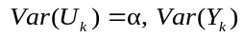, how much is the minimum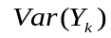?
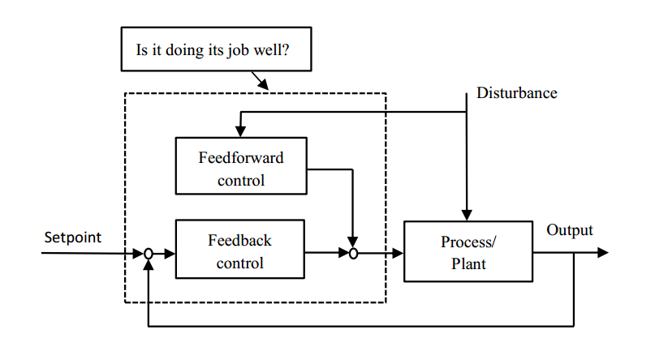
Fig. 1. Typical closed-loop process
Through the performance trade-off curve that is also known as the performance limit curve, the optimal performance can be achieved. This performance trade-off curve can be solved by solving the problem:
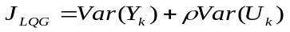 (1)
Under the condition of varying the weighting factor, the different optimal input and output variance can be obtained. The performance trade-off curve can be drawn with the optimal input variance as the horizontal axis and the optimal output variance as the vertical axis, then we can get the lower limit of the linear controller performance and the performance index of the input and output variance (see Fig.2).
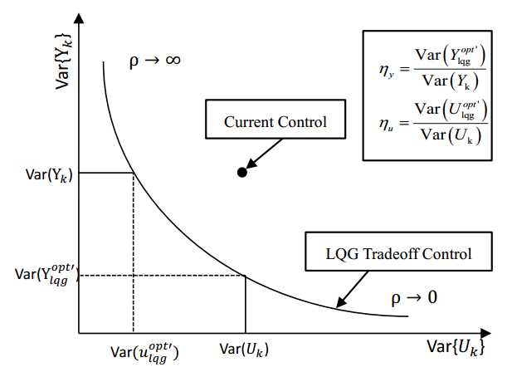
Fig. 2. The limit curve based on LQG performance
Depending on the existence and the form of the system model, the method of solving the LQG optimal control law can be divided into the following four types. When the model is a state space model, the classical state space model based algorithm or the MPC algorithm can be used. When the model is an auto-regressive moving average with exogenous (ARMAX) model, the polynomial algorithm can be used. When the model is unknown or the model parameters are difficult to be obtained, the closed-loop subspace method is used. This paper focuses on the LQG benchmark algorithm for the case with known system models.
2.1 LQG benchmark algorithm
The LQG performance benchmark is an extension of the MVC benchmark, which takes into account the variance of the system output and the control input. Therefore, the LQG performance benchmark can provide more information on the controller performance. The computational burden of the Riccati equation is very large when the LQG is used as the performance benchmark. Therefore, when the prediction horizon and the control horizon are approaching infinite, the LQG benchmark is solved by the approximation of solving the MPC, which can simplify the acquisition of the trade-off curve and is briefly described herein[15].
Consider the single-input single-output discrete-time processes:
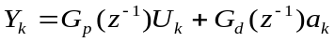 (2)
where, 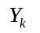and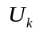are the process output and input, respectively; 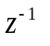is the back-shift operator; 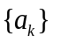is the variance of discrete white noise sequence with the zero mean value. The transfer function of the process and disturbance are described as follows:
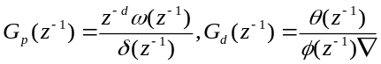 (3)
where, the polynomials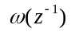,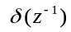, 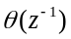 and 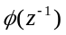are defined as:
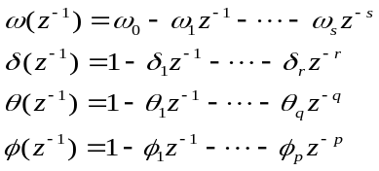 (4)
where, is the time delay of the system, and 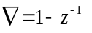is the difference operator.
A quadratic optimization function is usually adopted in the infinite time-domain MPC, and the structure is as follows:
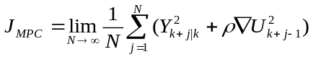 (5)
where, is the prediction horizon, 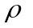is the weighting factor, 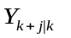is the predicted value for the future time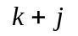at current time. 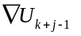is the control input for the future time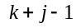.
Here 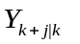can be calculated by the following simplified perturbation model:
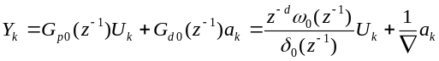 (6)
where, the subscript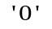indicates the parameters in the controller with the perfect process model.
Based on MPC, the closed-loop output of the system can be described as:
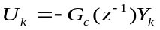 (7)
where, 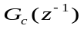is the transfer function.
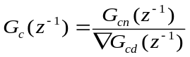 (8)
Here, 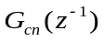 and 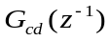 have the same forms as 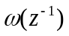 in Eq. (4).
If the time delay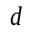 is known, the LQG performance index can be achieved while minimizing the objective function in the optimization algorithm, as pointed out by Huang and Shah [9]:
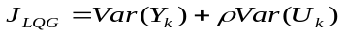 (9)
Therefore, the LQG optimization problem is solved by spectral decomposition [16] and the exact expression of MPC controller can be obtained:
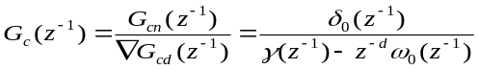 (10)
where, the polynomial 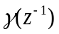is a reversible factor for spectral decomposition satisfying:
(11)
For the design of the controller, only the simplified process model is used.
For convenience, the operator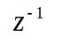is omitted from the following formula.
According to Eq. (2), Eq. (7) and Eq. (8), we can obtain
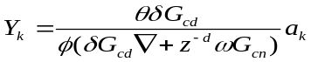 (12)
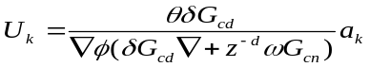 (13)
Based on the Parseval theory, the variance of the control input and the output of the closed-loop system can be obtained by the following operations:
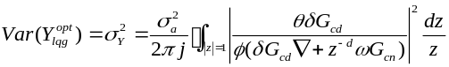 (14)
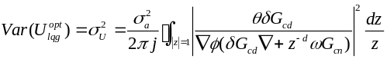 (15)
2.2 Trade-off curves and the indicators
For the range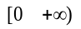and according to the above algorithm, we can get different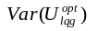and 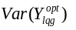values for differentvalues. Then we can draw the trade-off curve that presents the control performance limit for which the PID, MPC and other linear controllers can only operate in the right area above the curve in Fig. 2.
Assume that the current input and output variances are 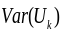and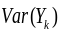, the optimal output variance of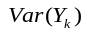corresponding to the trade-off curve is 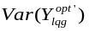, and the optimal output variance of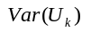corresponding to the trade-off curve is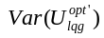, then the current control performance can be reflected by defining two indicators of the input and output variances:
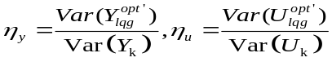 (16)
Obviously, both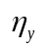and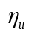vary between 0 and 1. In case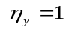, it means that for a given input variance, the controller achieves the optimal output variance; otherwise, there is room for improvement in the process output accordingly. Similarly, in case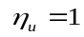, it means that for a given output variance, the controller produces an optimal input variance; otherwise, there is room for reduction.
3 Principle of IMC-PID
In this paper, we use IMC-PID to control the temperature of an industrial heating furnace and the control block is shown in Fig 3.
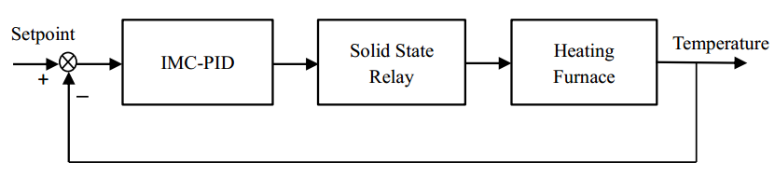
Fig.3. The block of IMC-PID for heating furnace
According to Ref. [17], the relationship between the PID parameters and the internal model controller is:
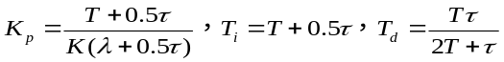 (17)
where,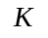is the system gain,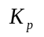is the proportional coefficient,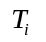is the integral coefficient, and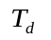is the derivative coefficient.
4. Case study
In this paper, the process is a SXF-4-10 type temperature control system of a furnace as shown in Fig. 4, and its rated voltage and rated power is 220V and 4KW, respectively.
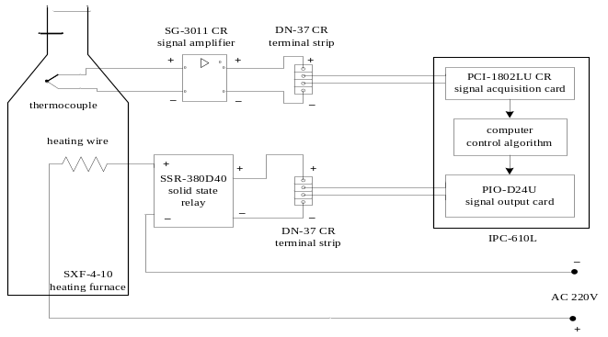 Fig.4. Process flow chart of the electric heating furnace (SXF-4-10).
4.1 Process Description
The temperature control system produces the required temperature for product heating. The process flow mainly consists of the temperature measurement with the K-type thermocouple, the industrial control computer and the execution part. The temperature of the furnace is collected through the PCI-1802LU converter and sent to the industrial computers for processing. After this, the temperature is compared with the desired temperature set-point and the corresponding control algorithm in the industrial control computer will calculate the corresponding heating amount required and send this requirement to the temperature execution module for implementation with the control of the off time of the relay.
4.2 Establishment of the heating furnace model
In the furnace system, a constant step input signal (20% duty cycles) was implemented until there are no significant temperature changes in the furnace, and the temperature of the heating furnace was sampled every 2 seconds during the heating process. The obtained temperature values are shown in Fig.5. The FOPDT model for the furnace is established using the two-point method described above:
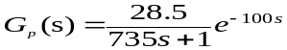 (18)
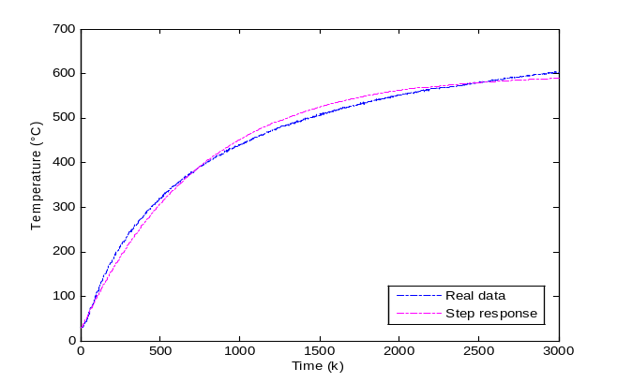
Fig.5. Step response of the furnace process.
Here the sampling time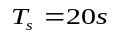is chosen in the discretization of the Eq. (18), and the discrete form of the model is:
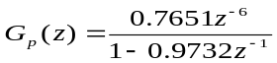 (19)
In the course of the experiment, the disturbance transfer function model is simulated as:
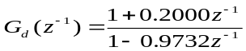 (20)
According to the Eq. (19) and Eq. (20), the discrete-time processes model of the furnace can be written as:
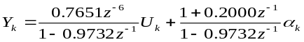 (21)
4.3 Experimental results
Through the experiment, we established the FOPDT model of the furnace and established the discrete model. We add the white noise 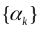 disturbance with the mean value of 0 and the variance of 0.1 to the temperature control system, then change the weight within a certain range, calculate the corresponding optimal input and output variance values and use the above LQG benchmark algorithm method to obtain the trade-off curve of the LQG benchmark, which is shown in Fig. 6.
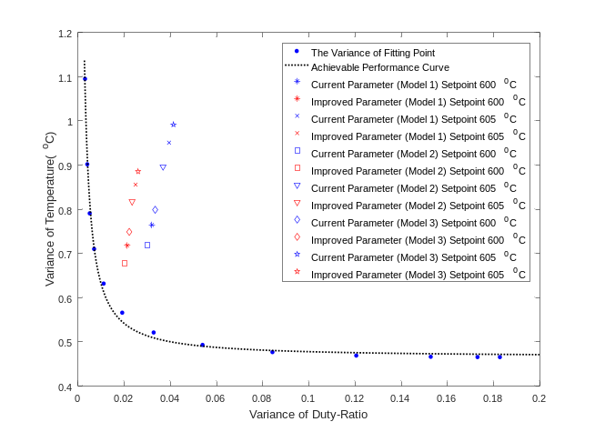
Fig.6. The limit curve based on LQG performance and actual variance of the system
The proportional, integral and derivative coefficients, according to the above IMC-PID principle, are:
Considering that the model and the actual process are difficult to match exactly in practice, we consider both the model match and the model mismatch cases in this paper, and the experimental results are shown in Fig.7a ~ 7c, with the model parameters:
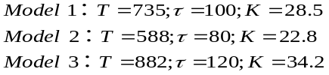
The corresponding experimental and simulation results for the three cases are shown from Fig. 7a to Fig. 7c.
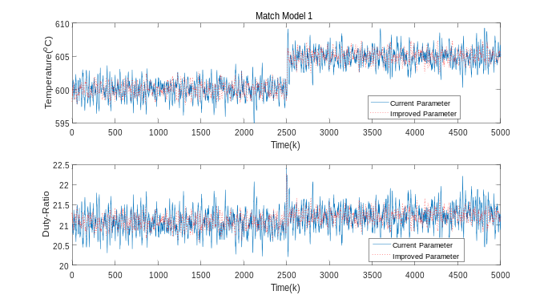
Fig.7a. The corresponding input and output of the different parameter (Model 1)
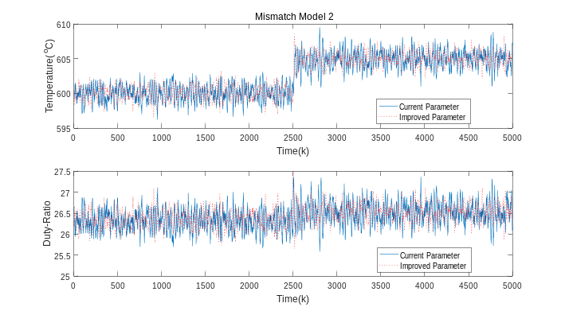
Fig.7b. The corresponding input and output of the different parameter (Model 2)
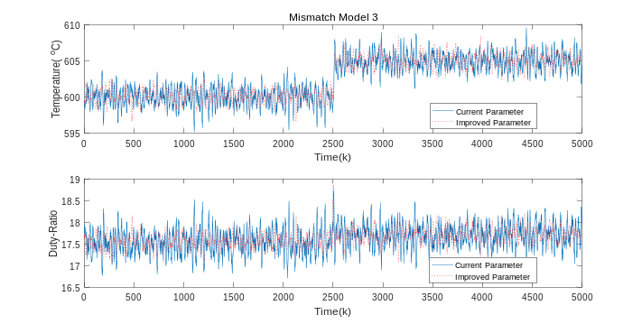
Fig.7c. The corresponding input and output of the different parameter (Model 3)
According to the experimental results, the input variance and the output variance in the model match and the model mismatch are shown in Table 1. The assessment of the performance of the control system has been performed according to the performance index defined above. When the heating furnace temperature set-point is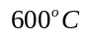, the performance index of the match model 1 is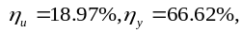and the performance index of the mismatch model 2 is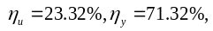 and the performance index of the mismatch model 3 is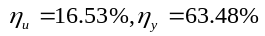. When the heating furnace temperature set-point is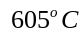, the performance index of the match model 1 is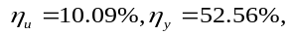 and the performance index of the mismatch model 2 is 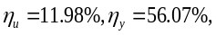 and the performance index of the mismatch model 3 is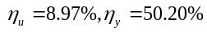. According to the above results, there is the relatively large room for improvement in the control performance.
Table1 Statistical results of steady state performance
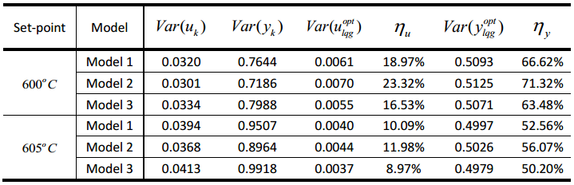
According to the results of the assessment and the simulation results, here the parameter of the IMC-PID controller as well as the integral and the derivative coefficients are adjusted by trial and error method. We chose one set of the controller parameters with the best control effect of the heating furnace, and the parameters are:
After adjustment and recalculation of the relevant data and performance index, the experimental and simulation results of the three different model parameters are further shown in Fig. 7a ~ 7c
When the heating furnace temperature set-point is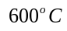, it shows that the performance index of the match model 1 is improved to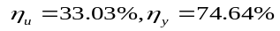, and the performance index of the mismatch model 2 is improved to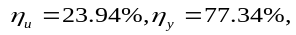 and the performance index of the mismatch model 3 is improved to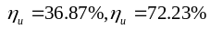. When the heating furnace temperature set-point is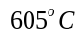, it shows that the performance index of the match model 1 is improved to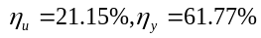, and the performance index of the mismatch model 2 is improved to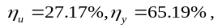and the performance index of the mismatch model 3 is improved to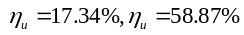. By re-adjusting the parameters, the control performance of the controller is greatly improved for both model match and model mismatch cases, as shown in Table 2.
Table2 Statistical results of steady state performance
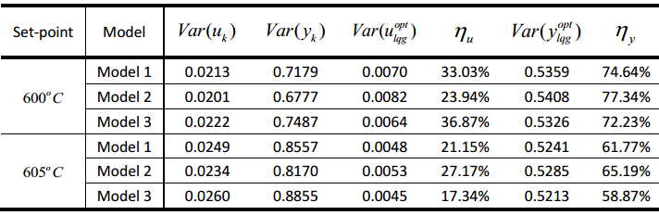
According to the experimental results, we obtained the actual input variance and output variance of the system under the conditions of the model match and the model mismatch before and after changing the controller parameters, whose specific values are shown in Fig.6. We can intuitively find that by adjusting the parameters of the IMC-PID, the input variance and the output variance are reduced to some extent under both the model match and the model mismatch cases and closer to the LQG trade-off curve, indicating that the control performance of the controller has been greatly improved after the parameters re-adjustment as expected.
In addition, for different heating furnace temperature set points, the actual input variance and output variance of the system before and after the controller parameter adjustment are compared for the model match and model mismatch cases, and the results are plotted as bar graphs in Fig .8a ~ 8b. According to the results, when the heating furnace temperature set-point is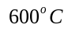, it is found that the corresponding input variance and output variance decrease by 14.05% and 8.02%, respectively, for the match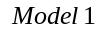, and those decrease 0.62% and 6.02%, respectively, for mismatch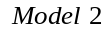, and 20.34% and 8.75%, respectively, for mismatch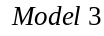.
When the heating furnace temperature set-point is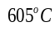, it is found that the corresponding input variance and output variance decrease by 11.06% and 9.2%, respectively, for the match, and those decrease 15.19% and 9.12%, respectively, for mismatch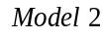, and 8.38% and 8.67%, respectively, for mismatch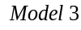. The decrease of the input variance is more obvious compared with that of the output variance, and the system tends to be under the control with the smallest energy. Through redesigning the controller parameters after the assessment of the system performance, the control performance of the system has been effectively improved for the model match and the model mismatch cases.
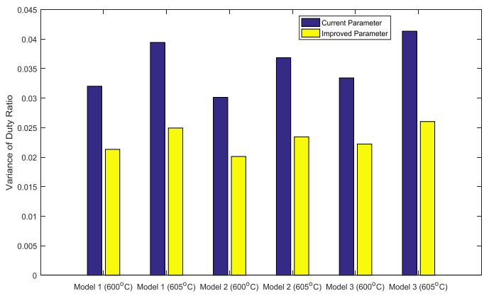
Fig.8a. The duty ratio’s variance of the system under current/improved parameter conditions
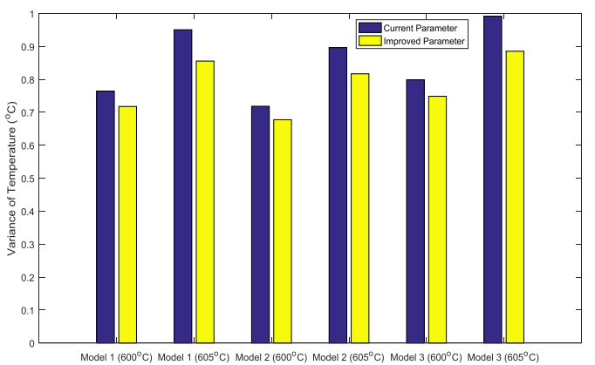
Fig.8b. The temperature’s variance of the system under current/improved parameter conditions
5. Conclusion
In this paper, we focus on the LQG benchmark based study of the control performance of model match and model mismatch of IMC-PID controller. The optimal control law is obtained by solving the linear quadratic Gaussian problem and the optimal input and output variance are determined for different weighting factors, then the performance limiting curve and the performance index of the input and the output variance are given. Finally, the performance assessment of the model match and the model mismatch based on the IMC-PID controller is carried out by using the LQG benchmark. The results show that there still exists a large room for improvement for the control performance. By re-adjustment of the parameters, the control performance of the controller is further improved and the lower limit of the performance of linear controller is given at the same time, which allows us to effectively evaluate the control performance of the controller when carrying out the heating furnace control experiment, and to take timely measurements and adjustments.
References
- Paulonis, M. A., & Cox, J. W. (2003). A practical approach for large-scale controller performance assessment, diagnosis, and improvement. Journal of Process Control, 13(2), 155-168.
- Jelali, M. (2006). An overview of control performance assessment technology and industrial applications. Control Engineering Practice, 14(5), 441-466.
- Kadali, R., & Huang, B. (2004). Multivariate controller performance assessment without interactor matrix - a subspace approach. IFAC Proceedings Volumes, 37(1), 535-540.
- Box, G. E., Jenkins, G. M., Reinsel, G. C., & Ljung, G. M. (2015). Time series analysis: forecasting and control. John Wiley & Sons.
- DeVries, W., & Wu, S. (1978). Assessment of process control effectiveness and diagnosis of variation in paper basis weight via multivariate time-series analysis. IEEE Transactions on Automatic Control, 23(4), 702-708.
- Ender, D. B. (1993). Process control performance: Not as good as you think. Control Engineering Practice, 40(10), 180-190.
- Harris, T. J. (1989). Assessment of control loop performance. The Canadian Journal of Chemical Engineering, 67(5), 856-861.
- Tyler, M. L., & Morari, M. (1996). Performance monitoring of control systems using likelihood methods. Automatica, 32(8), 1145-1162.
- Huang, B., & Shah, S. L. (2012). Performance assessment of control loops: theory and applications. Springer Science & Business Media.
- Pour, N. D., Huang, B., & Shah, S. L. (2010). Performance assessment of advanced supervisory–regulatory control systems with subspace LQG benchmark. Automatica, 46(8), 1363-1368.
- Wang, X., Huang, B., & Chen, T. (2007). Multirate minimum variance control design and control performance assessment: a data-driven subspace approach. IEEE Transactions on Control Systems Technology, 15(1), 65-74.
- Yang, H., & Li, S. (2012). Data-driven subspace approach to MIMO minimum variance control performance assessment. In Intelligent Control and Automation 10th World Congress on (pp. 3157-3161).
- Huang, B. (2003). A pragmatic approach towards assessment of control loop performance. International Journal of Adaptive Control and Signal Processing, 17(7-9), 589-608.
- Horton, E. C., Foley, M. W., & Kwok, K. E. (2003). Performance assessment of level controllers. International Journal of Adaptive Control and Signal Processing, 17(7-9), 663-684.
- Julien, R. H., Foley, M. W., & Cluett, W. R. (2004). Performance assessment using a model predictive control benchmark. Journal of Process Control, 14(4), 441-456.
- Ruan, X., Bien, Z., & Park, K. H. (2005). Iterative learning controllers for discrete-time large-scale systems to track trajectories with distinct magnitudes. Taylor & Francis, Inc.
- Leva, A., & Maggio, M. (2012). Model-based PI(D) auto-tuning. PID Control in the Third Millennium. Springer London.

 

